Putting Hedgerley on the Map:
From Gough to Google.

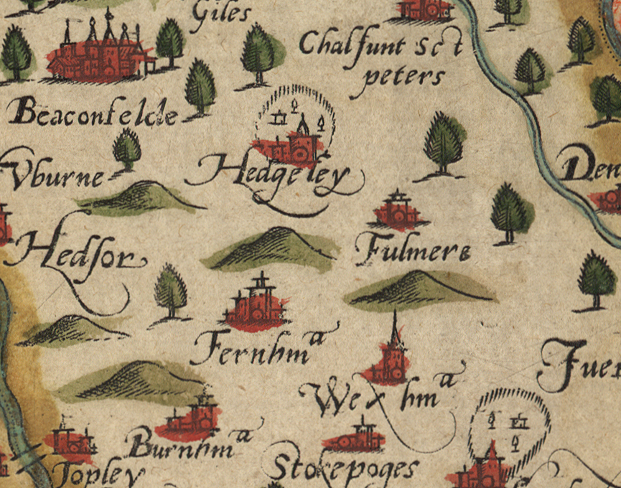

Saxton 1574 – Hedgerley on the map for the first time.

Producing maps and plans is a basic and ubiquitous human activity; maps have been produced by most civilisations. In Britain the first map of the whole country with serious geographic content is the ‘Gough Map’, one of the great medieval treasures of cartography in the collection of the Bodleian Library, Oxford. It is named after Richard Gough (1735-1809) whose superb collection of maps, atlases and other topographical works was bequeathed to the Bodleian Library in 1809 and formed the foundation of its superb topographical collection. This manuscript map was produced in the late 13th or early 14th century and is remarkably geographically accurate. It is the first map on which the towns and villages of Buckinghamshire are seen in their geographical context.

From the 16th century onwards, the mapping of Britain was done principally either at the county level or, for major conurbations, at the town or city level.

The first comprehensive mapping of England and Wales after the Gough Map was conducted by a Yorkshire surveyor, Christopher Saxton, starting in 1570 and finishing in 1579 when his atlas of all the English and Welsh counties was published. The map showing Oxfordshire, Berkshire and Buckinghamshire was issued separately in 1574. Saxtons maps were comprehensive, accurate and aesthetically pleasing and were the basis of all county maps until the middle of the 18th century.

The first set of maps based on (in fact slavishly copying) Saxton’s maps was produced to illustrate the 1607 edition of William Camden’s Britannia, the first great ‘chorographical’ history of Britain. This was the earliest map of Buckinghamshire shown on its own.
A friend of Camden’s, John Speed, produced his own history of Britain and accompanied it with the ‘Theatre of the Empire of Great Britaine’ probably the most famous early atlas of them all. It is a beautiful atlas but derived directly from Saxton’s work. Speed admitted that ‘I have put my sickle in other men’s corne’.

Roads had not been seen as an essential feature on maps throughout the 16th and the first half of the 17th centuries. This changed in 1675 when John Ogilby after a life of much variety, hardship and achievement, produced his own Britannia for which he surveyed and drew all the main roads in the country. Ogilby’s Britannia transformed the ability of mapmakers to depict roads.

Thomas Kitchin and Emanuel Bowen produced the Large English Atlas issued as a part work from 1749 to 1760, for the first time using the genuinely latest surveys of individual counties, rather than simply re-hashing Saxton. This raised the overall standard of mapping in the country, but it was still far inferior to the mapping of France where, under the influence of the Cassini mapping dynasty, scientific methods were used to set a whole new level of accuracy.

This situation caused a general level of political concern, and in the middle of the 18th century, inspired by a prize given by the Society for the Encouragement of Arts, Manufactures and Commerce (now the RSA), high quality large scale maps began to be produced of many counties. This led to Thomas Jefferys map of Buckinghamshire at 1” to the mile being published in 1770. As a result of the creation of the RSA scheme, more than 35 counties were mapped at a high level of accuracy and at large scale – but only 13 maps won the prize.

The threat of invasion by Napolean led to the establishment of the Ordnance survey in 1791. From the beginning of the 19th century, Ordnance Survey maps covered the whole of the country; 1 inch to the mile maps of Buckinghamshire were issued in 1822.. From the 1870s onwards the Ordnance Survey produced maps at 6 inches and 25 inches to the mile. For towns with a population greater than 4,000 they produced maps at 10 feet to the mile (!). A full set of these extremely detailed maps was made of Buckinghamshire. Throughout the 19th and 20th centuries, the Ordnance Survey produced the best maps of any country in the world.

Today, though, detailed, national mapping is no longer solely in the hands of a state monopoly. The development of various technologies – particularly photography of terrain from the air and from space, the Global Positioning System (GPS) and sophisticated cartographic software – has enabled many new entrants into the mapmaking field. The dominant force is Google, who through Google Maps and Google Earth, now produce highly detailed maps – both as orthodox maps and photographic imagery – for most of the world.

… a long way from the Gough map.

John Leighfield
October 2024

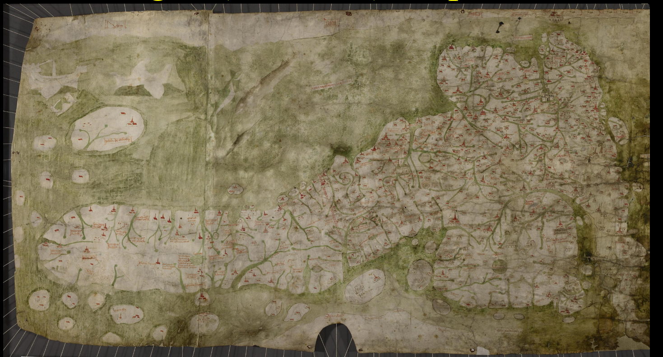

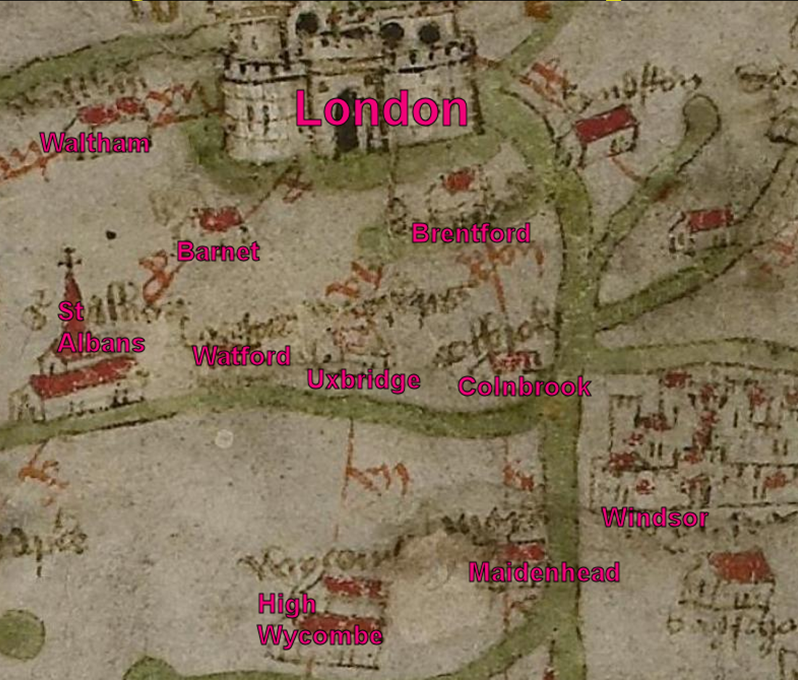
“Gough” (Bodleian) Map ca1400
The Gough map is one of the great medieval treasures of cartography. It is extraordinary in the detail it shows (more than 600 toponyms) and for its accuracy. It is the subject of continuing academic reaerch to unveil the many questiond that it provokes.
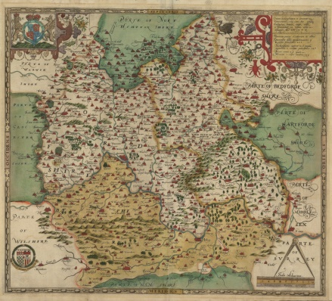
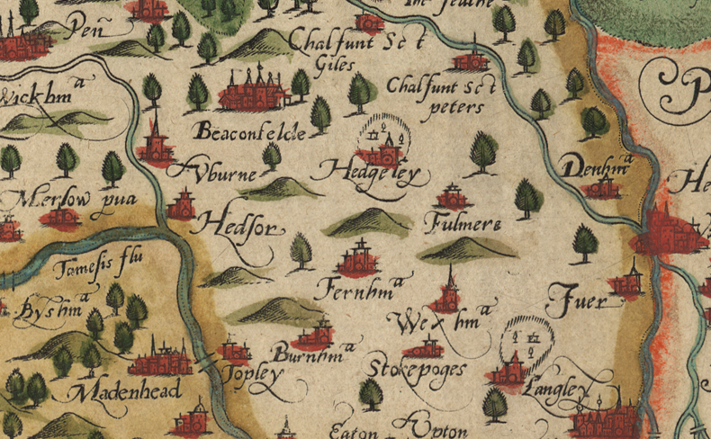
Christopher Saxton – 1574
Between 1570 and 1579, Saxton surveyed, drew, and had engraved, maps of all the counties of England and Wales. This amazing achievement created mapping that was the basis of the maps of all the counties for almost 200 years. He was indeed ‘the father of British mapmaking’.

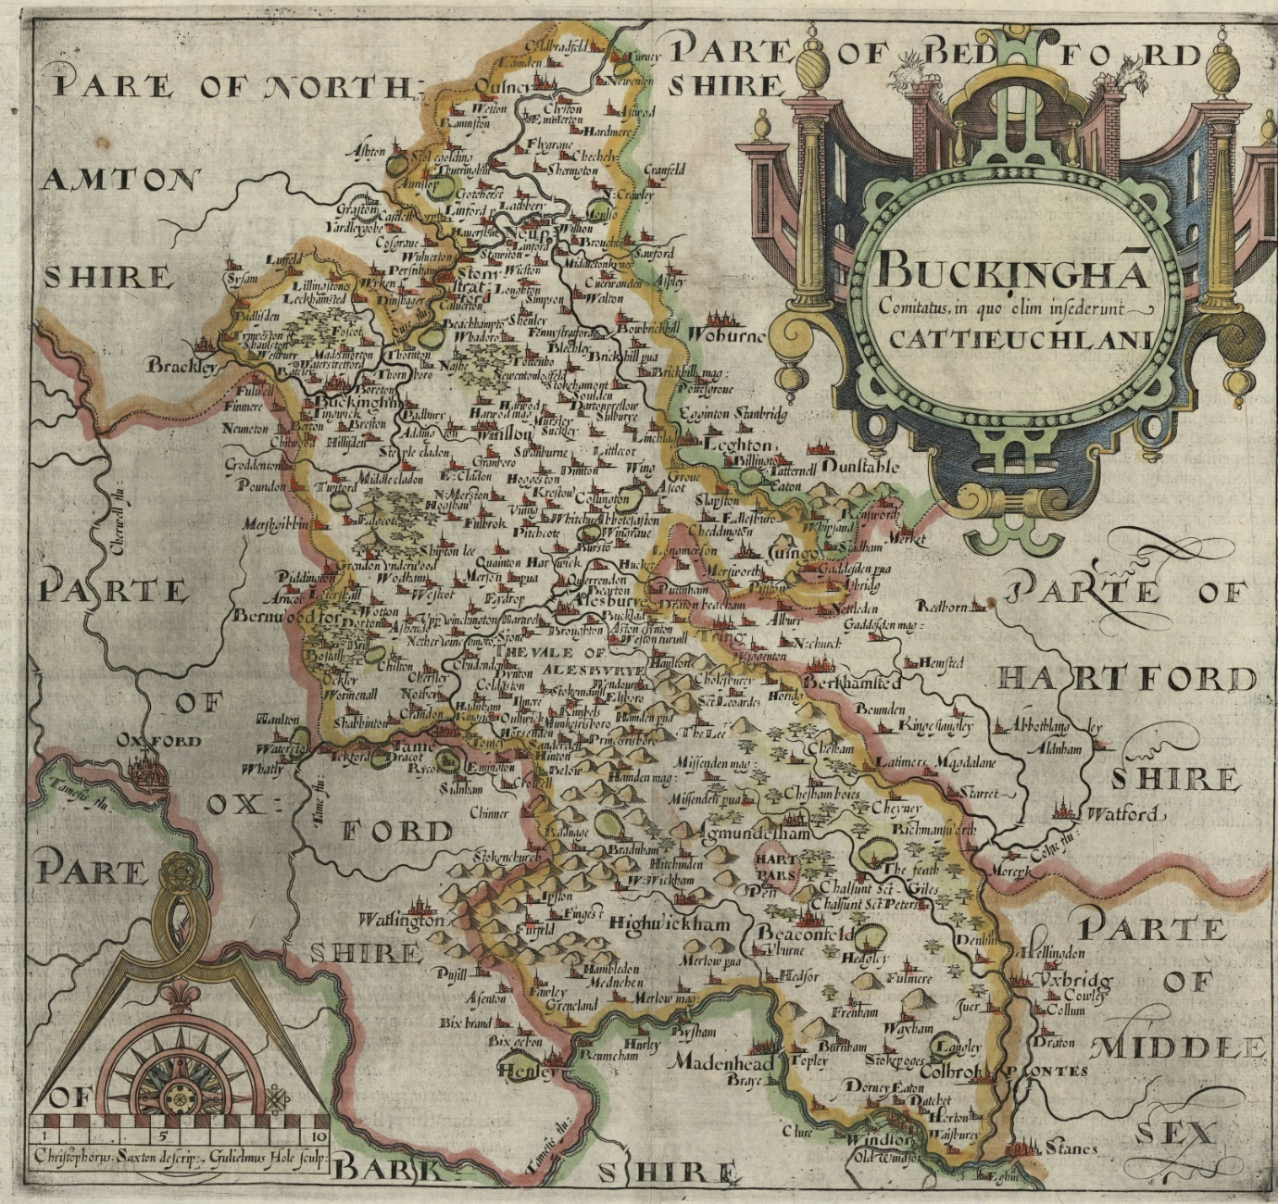

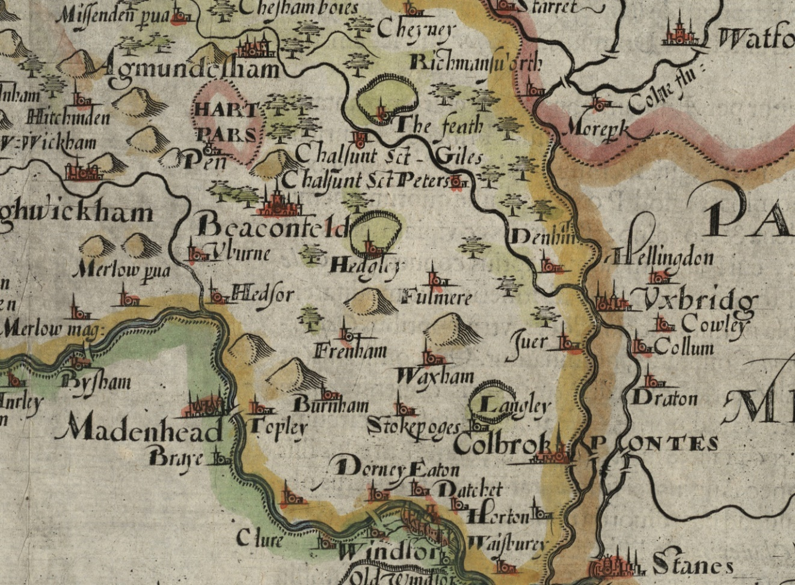
Camden’s Britannia - Saxton/Hole – 1610
A copy of Saxton’s map, slightly enlarged, to illustrate the sixth (onwards) editions of William Camden’s Britannia. It is the first map showing Buckinghamshire on its own.

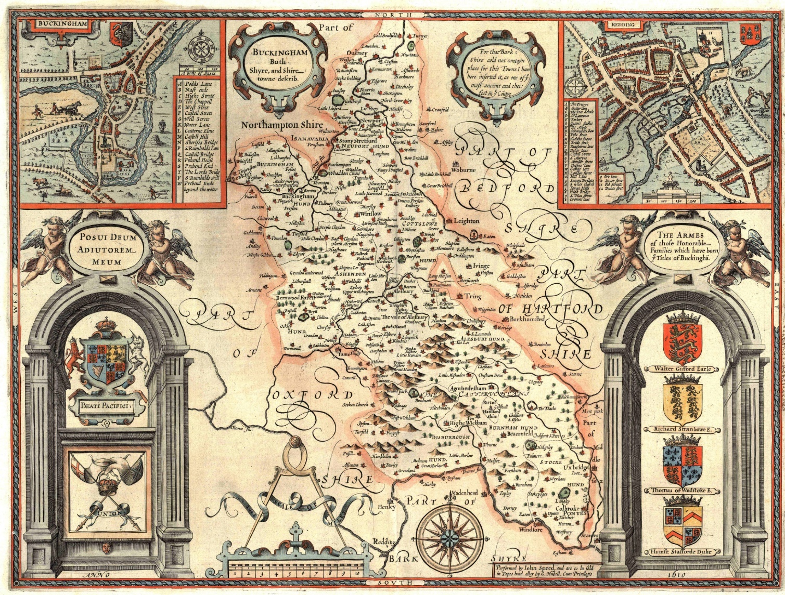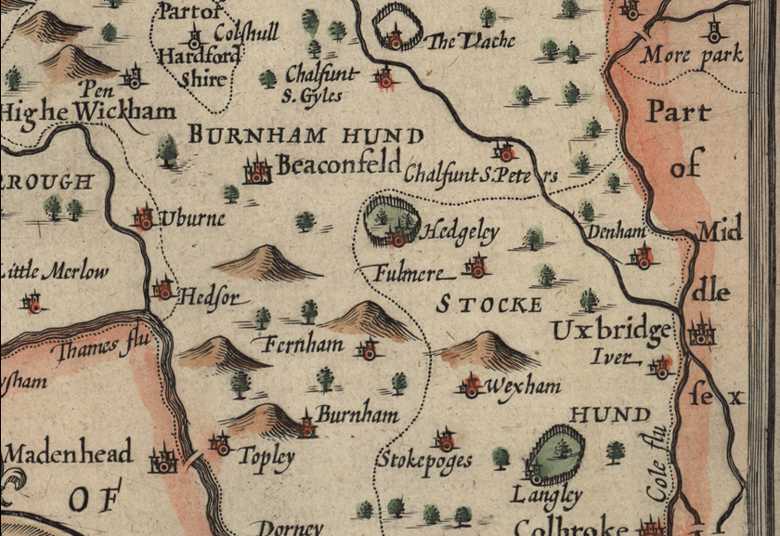
John Speed - 1611
From The Theatre of the Empire of Great Britaine. Bringing a new level of decoration to maps. The maps were produced as an appendix to Speed’s history of Britain (based on Camden’s Britannia).
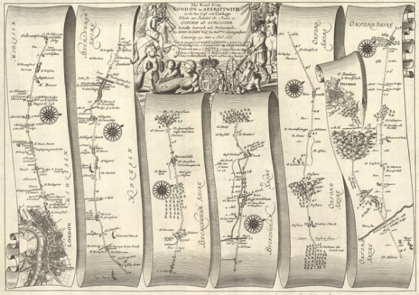

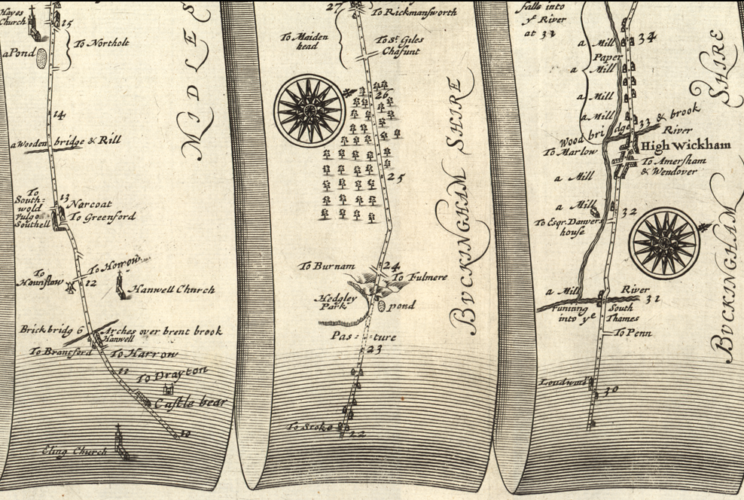
John Ogilby (London to Oxford) – 1675

From Oxford to Aberystwyth, the first plate (of 100) in his Britannia showing the road from London to Oxford. The first atlas of the roads of Britain. Surveyed at 1 inch to the mile.

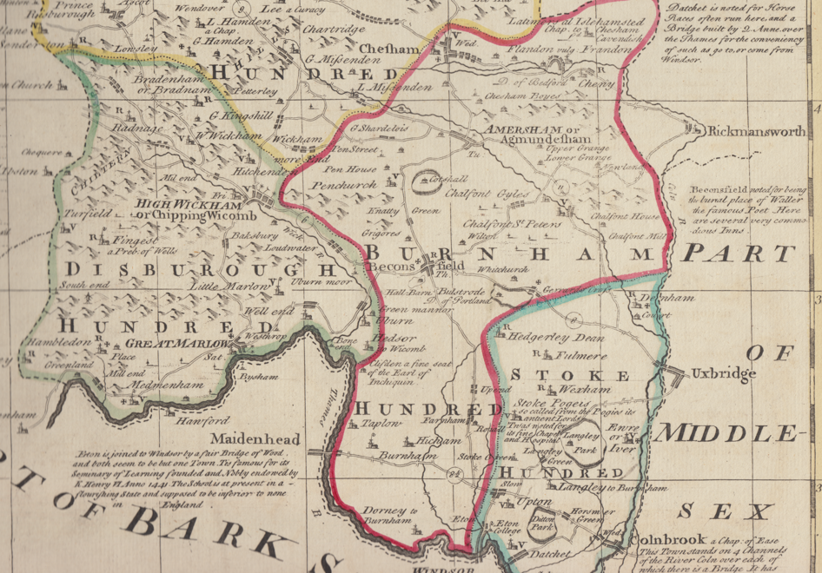

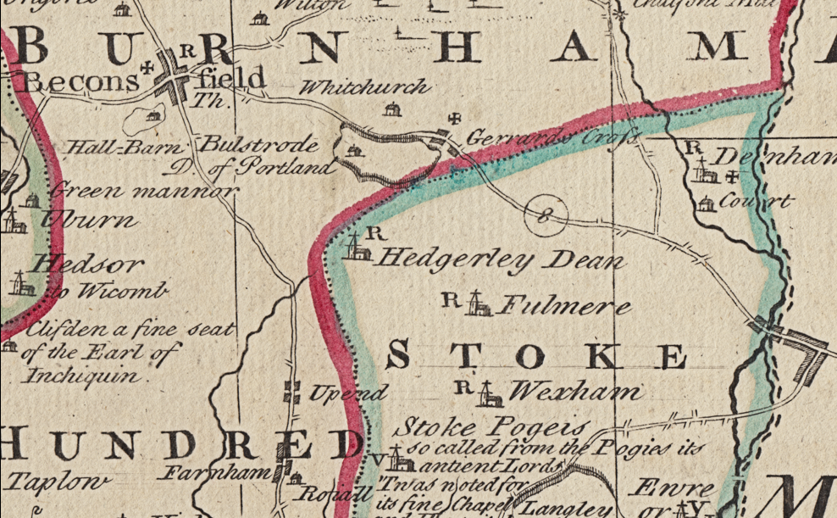
Thomas Kitchin and Emanuel Bowen – 1760

From the Large English Atlas, the first county atlas of the country that did not rely primarily on the topographical information of the maps of Saxton (or Speed). Largish scale and fairly accurate.

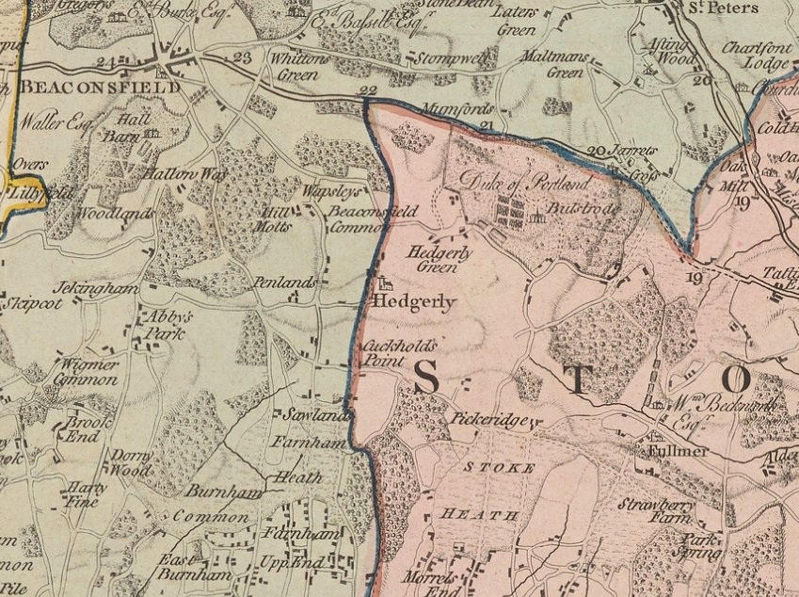

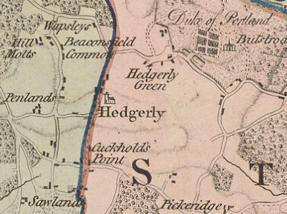
Jefferys – 1700

The first 1” to the mile map of Bucknighamshire prepared as an entry for the RSA prize that was established to put the mapping of the counties on a professional level.
Jefferys –- 1770
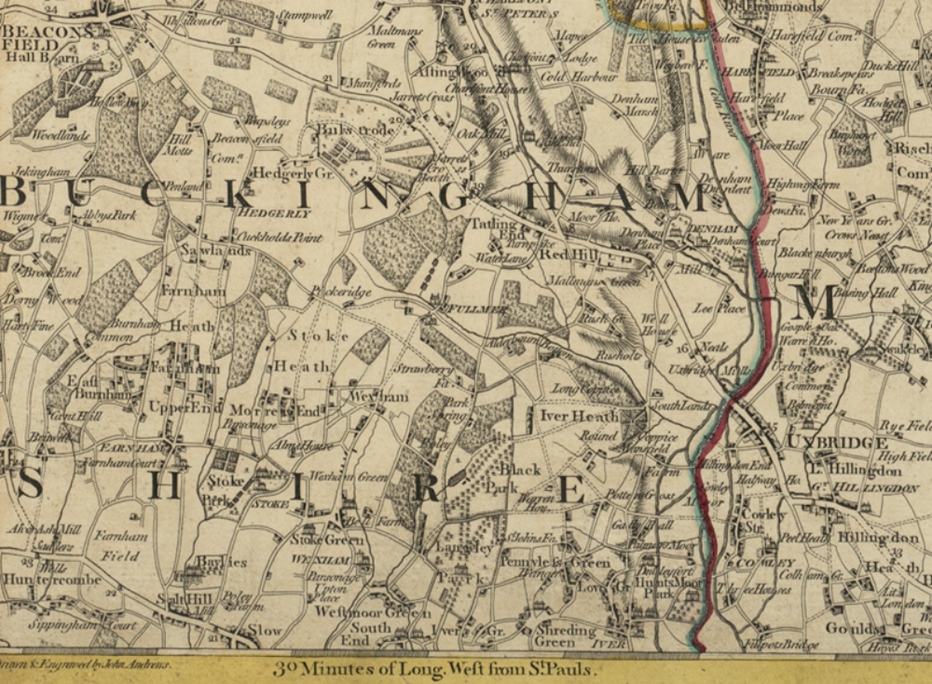

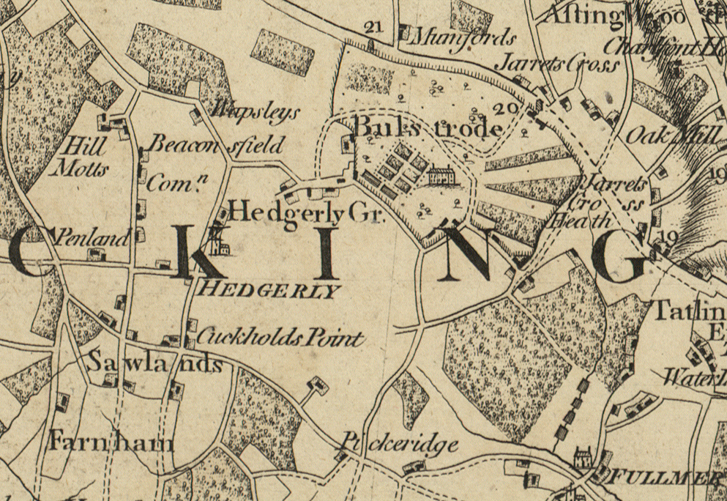
Andrews & Dury 1” to mile – 1777 (25 miles round Windsor)
A detailed, accurate, large scale map catering for the rapid development of travel, especially in the environs of London, in the final quartet of the 18th century.

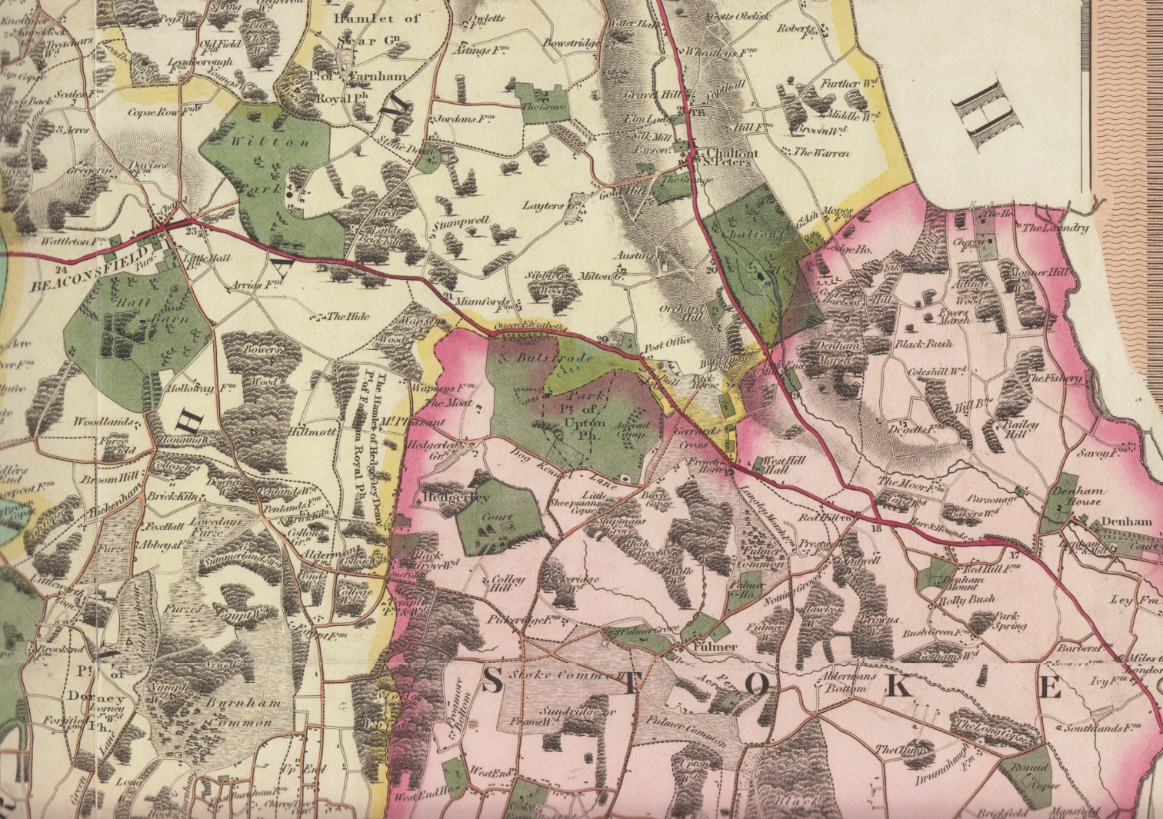

Bryant 1823

A beautiful large scale map of the county, the last produced commercially before the arrival of the Ordnance Survey made such commercial enterprises unviable.

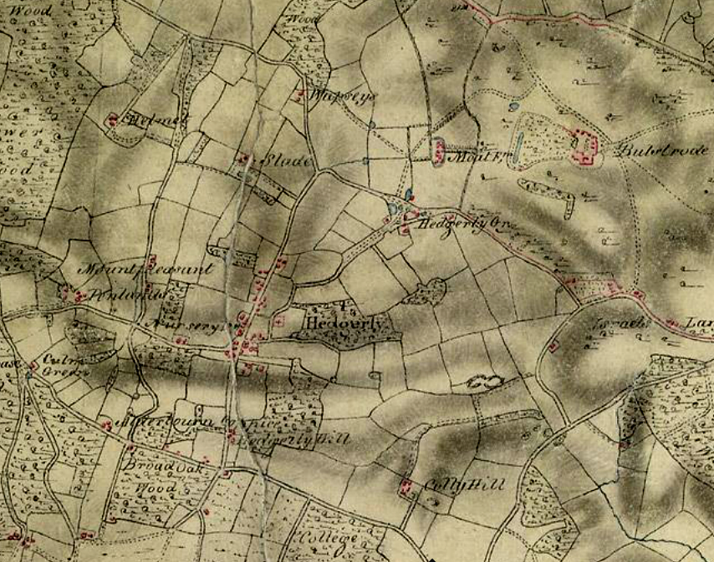
Ordnance Survey 1” to mile – Surveyor’s Drawing 1811 – ‘Uxbridge’

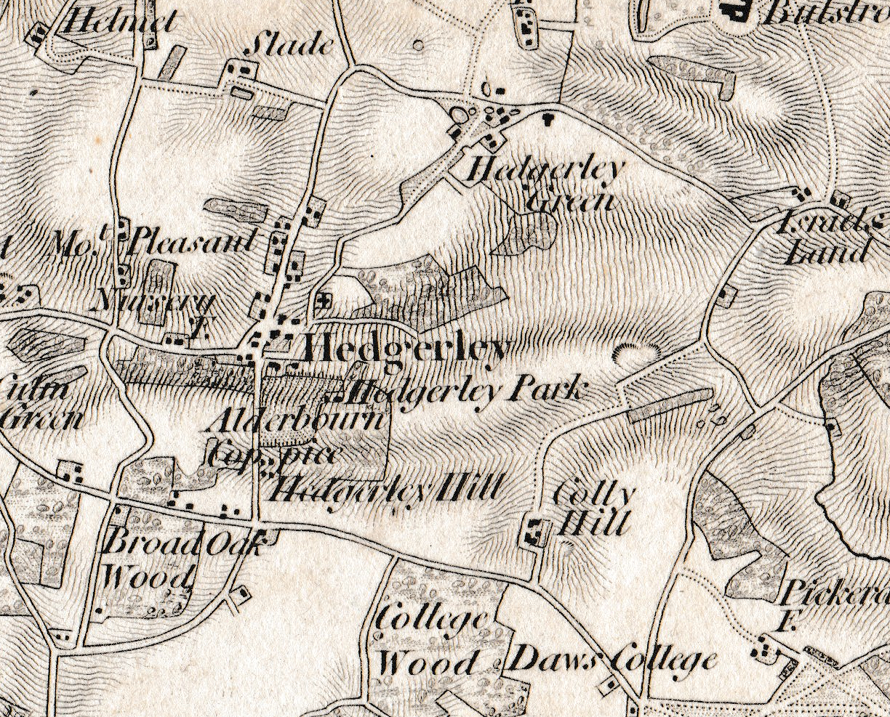
Ordnance Survey 1” to mile – 1822

Starting with Kent, the surveyors’ drawing, were combined as in a gigantic jigsaw puzzle to produce a complete, highly accurate map of the whole country with common conventional symbols and a superb quality of engraving.
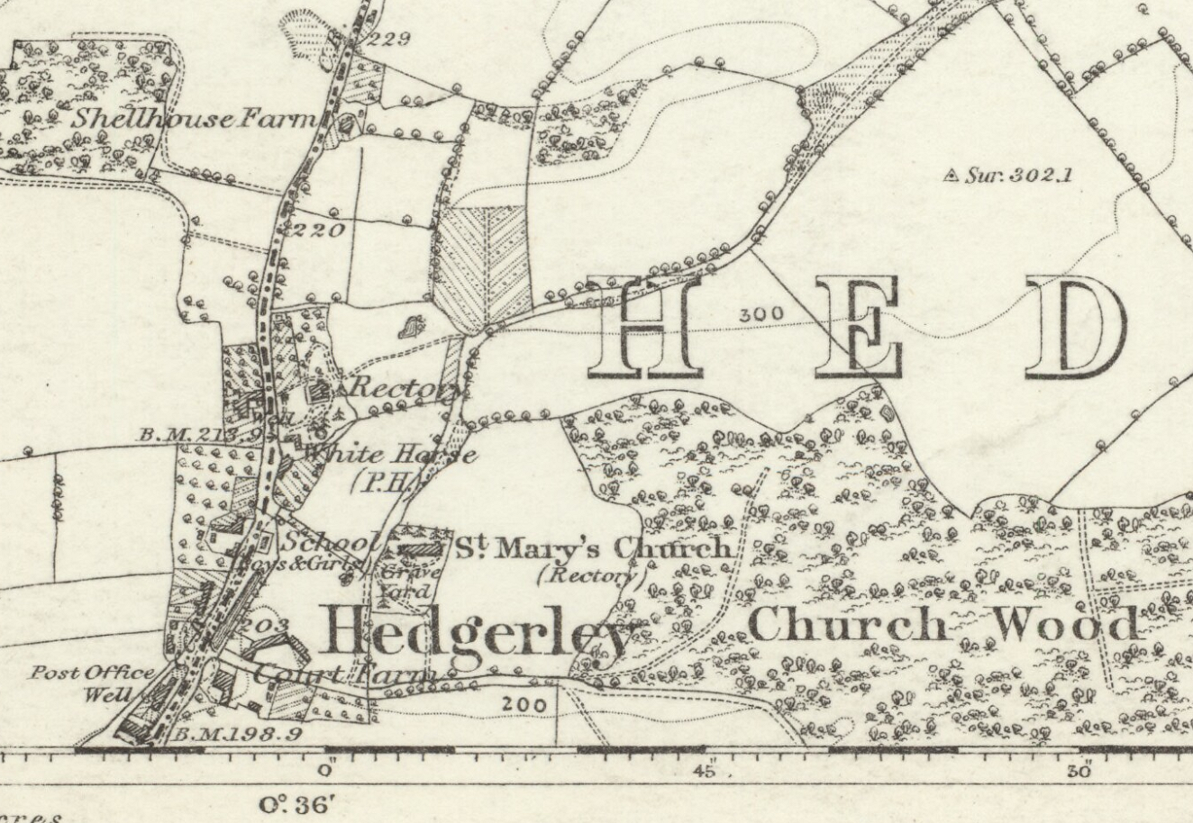
Ordnance Survey 6 inches to the mile - 1887
The Ordnance Survey six-inch to the miles series is the most detailed topographic mapping that covers all of England and Wales from the 1840s to the 1950s.

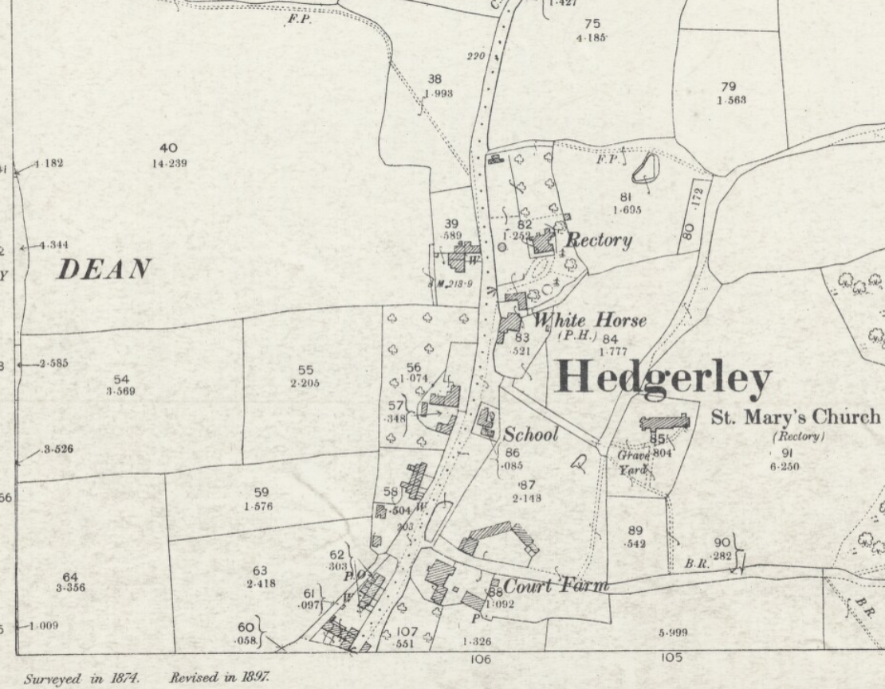
Ordnance Survey 25 inches to the mile - 1876
The Ordnance Survey 25 inch to the mile is the most detailed Ordnance Survey mapping for most parts of England and Wales. The maps allow practically every feature in the landscape to be shown.

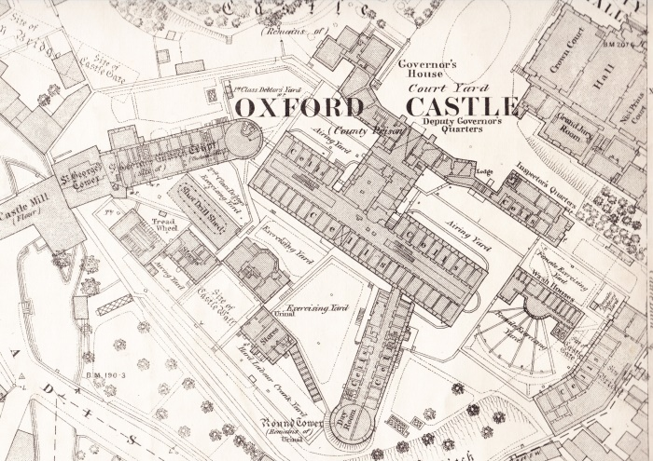

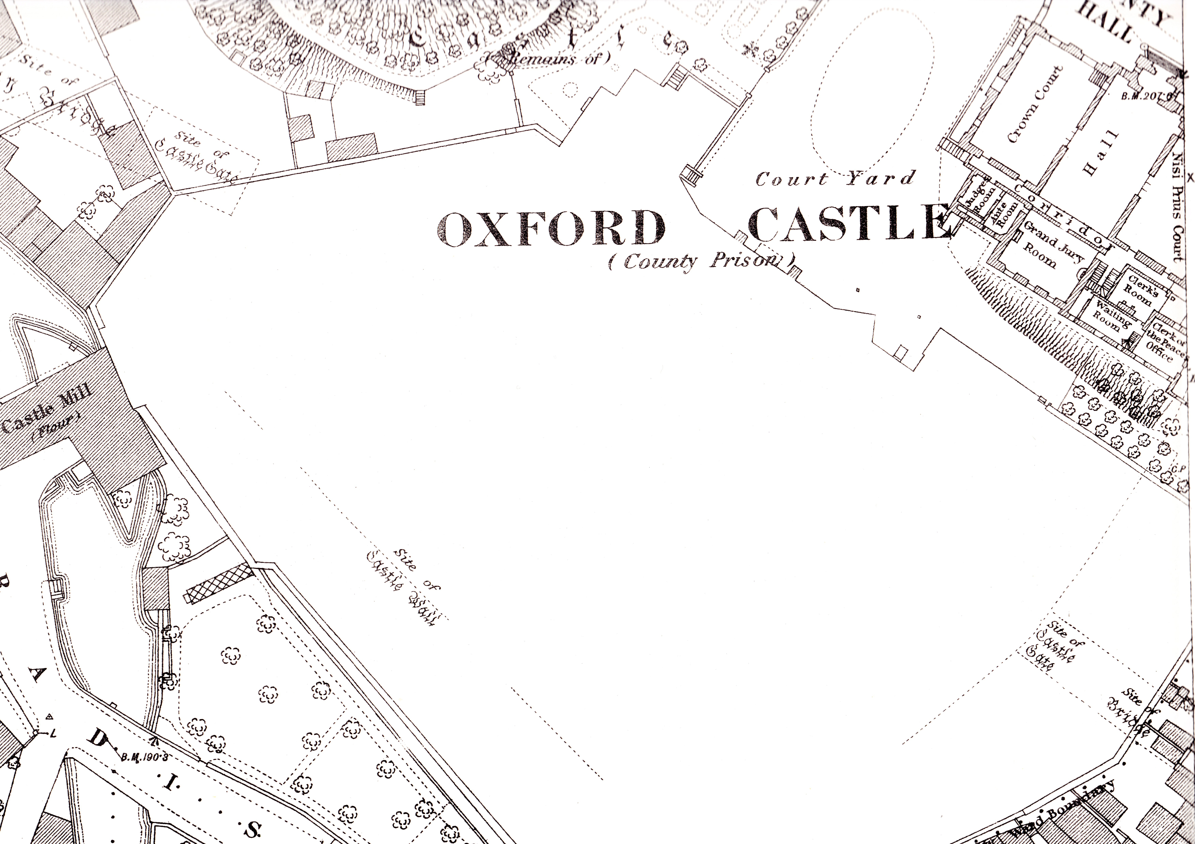
Ordnance Survey 10 feet to the mile – 1876 and 1878

Maps at this amazing scale were produced for all towns with a population greater than 4,000. This map shows the Oxford Castle and the county gaol in all its gory detail – until censored a couple of years later.

